**Exercise 1: Java.**

Name: Basic Utils

Requirements:

1.- Create a new application, it should show a menu in console, this menu should have the next options:

1.- Basic calculator

2.- Encoder

3.- Student average calculator`

2.- The program should be able to read all the values from console.

3.- For option 1, we need to create a basic calculator, should be able to process 4 basic operations (sum, subtract, multiply and divide), for this exercise is recommended use a functional interface, in case you can´t implement, use normal methods.

Note: Remember that we cannot divide numbers / zero.

4.- For option 2, we need to create an encoder and decoder, the function for this is only to enter an string and be able to encode it to Base64 or decode a Base64 string to normal word.

5.- For option 3, we need to create an average calculator for students, its inputs will be: name, grade, signatures number, name and score are required for each signature. The result will be a little report with the final score and the status of the student. For this exercise is recommended use Maps and Streams, to review those lessons.

Application flow:

1. Open a menu in console:

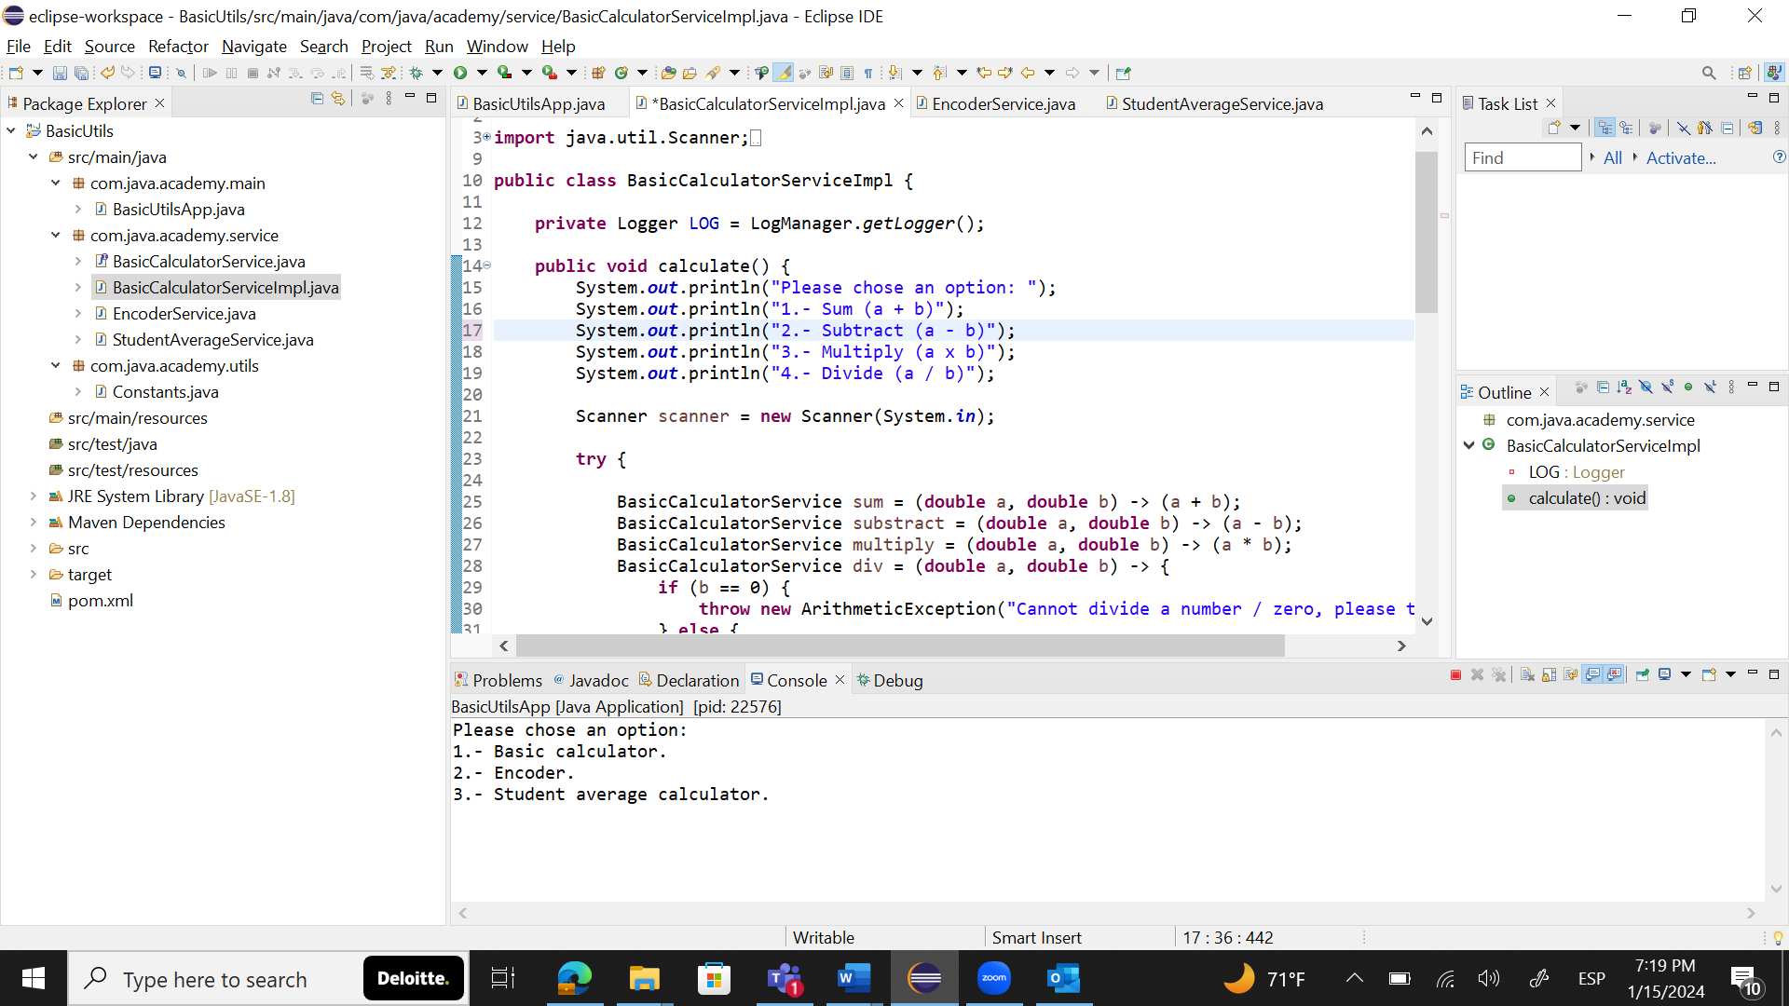

**Basic calculator.**

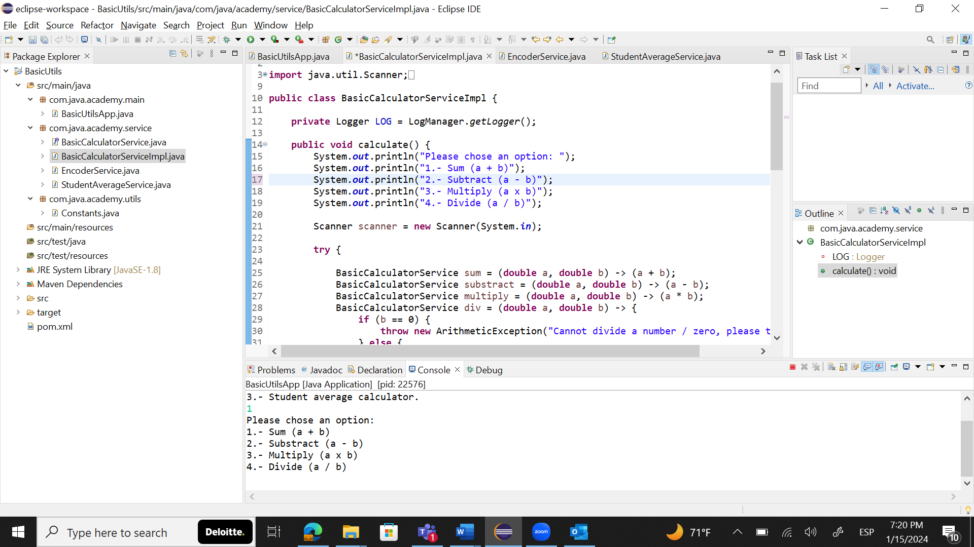

Sum:

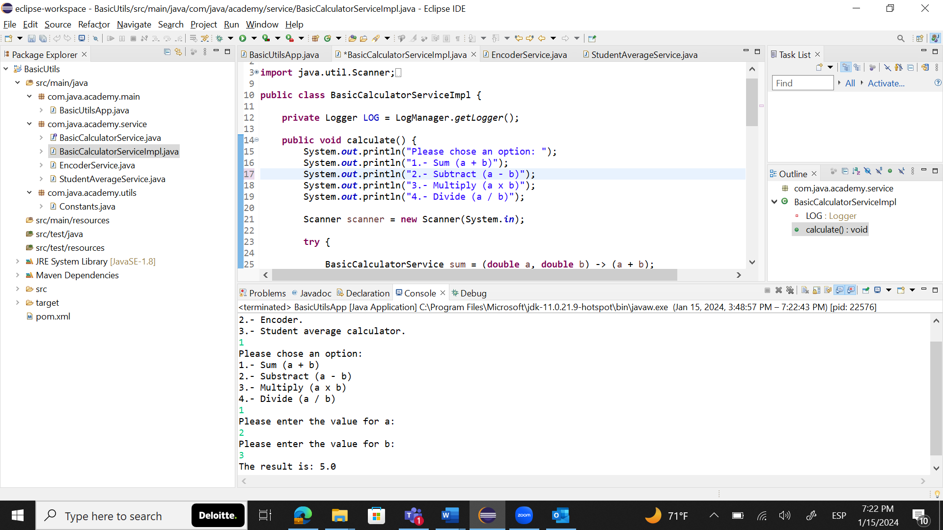

Subtract:

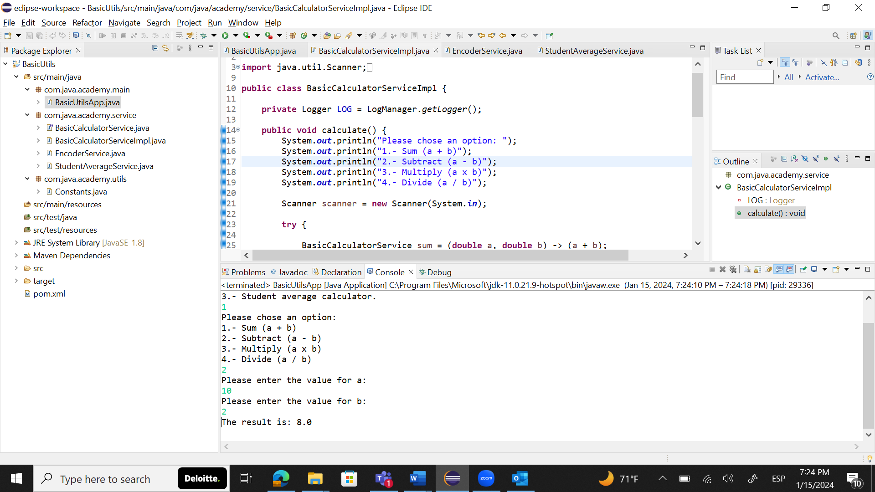

Multiply:

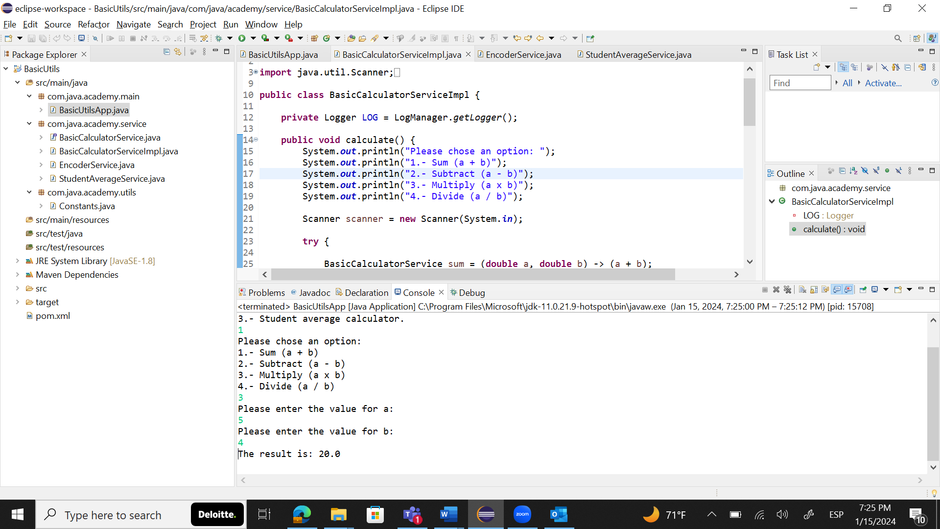

Divide:

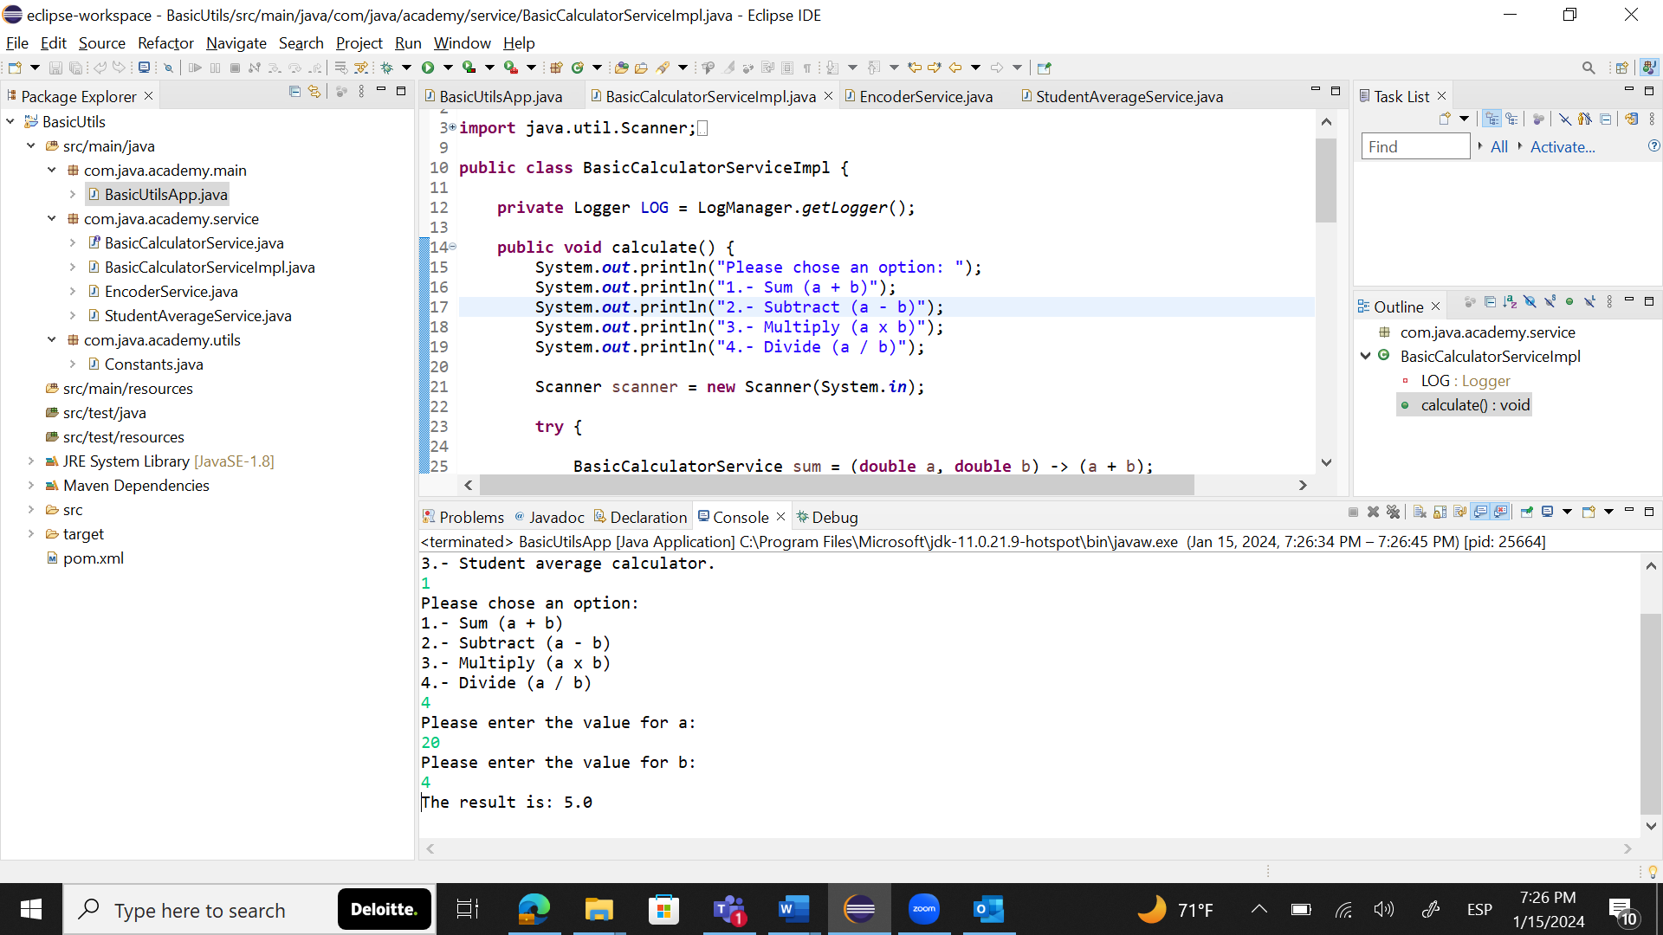

**Encoder**

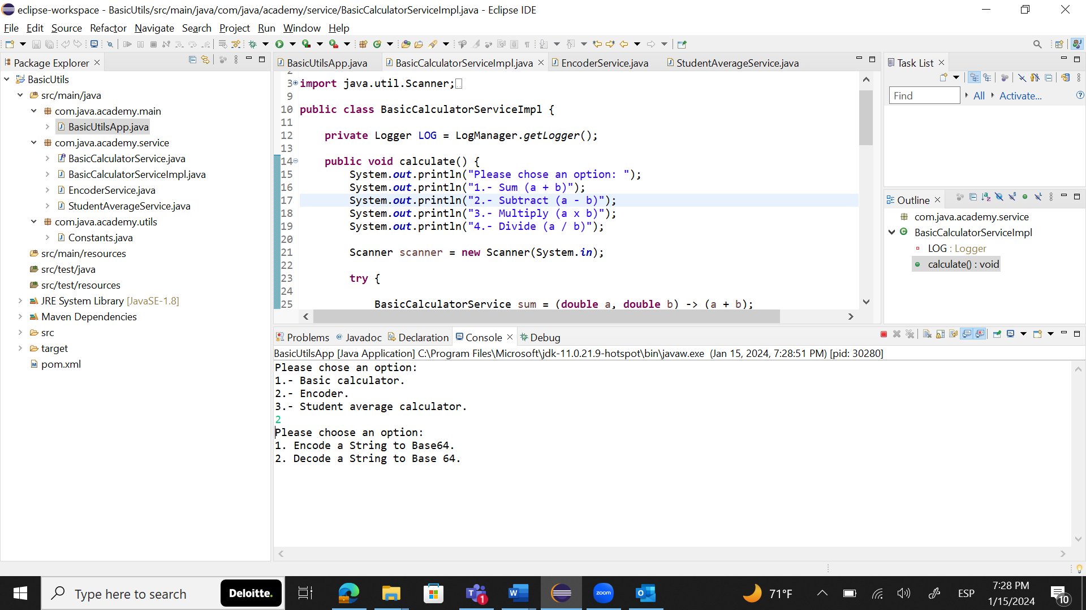

Encode

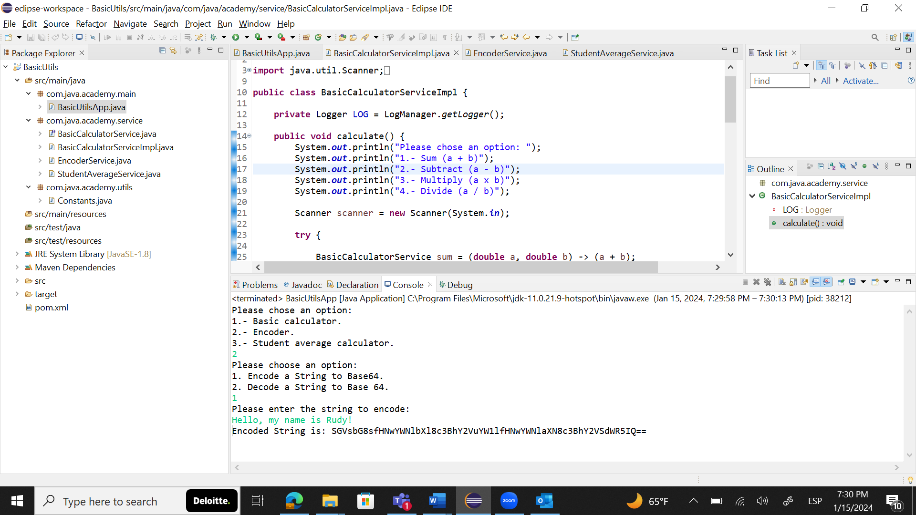

Decode

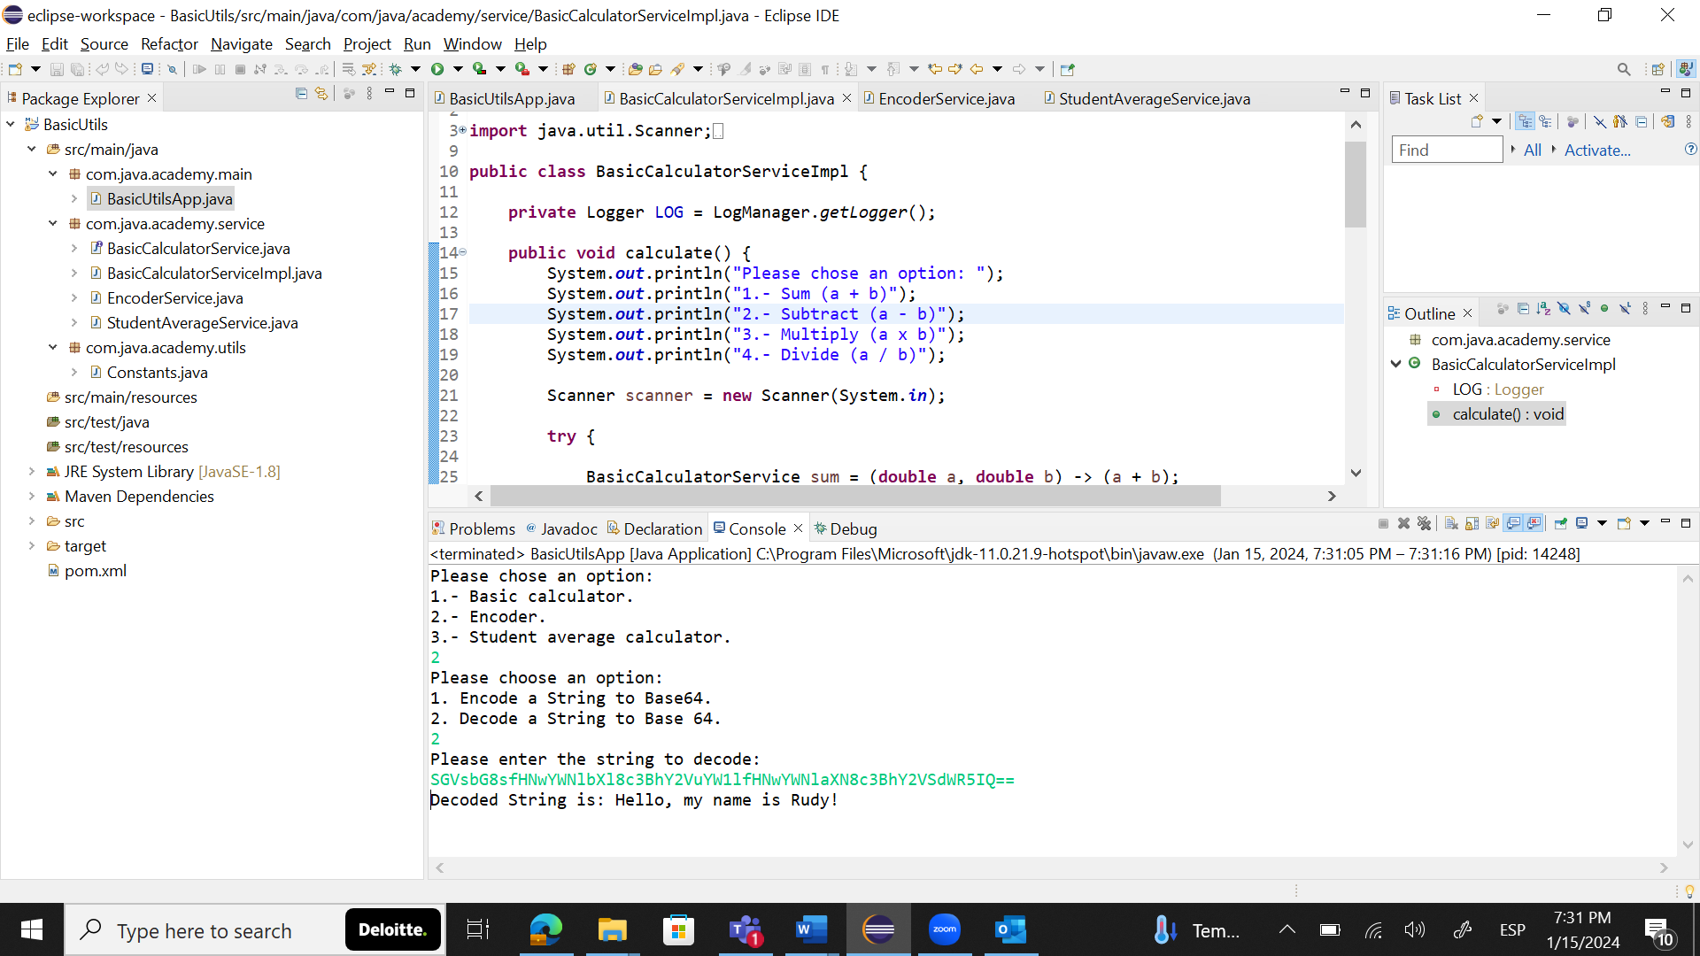

**Student Average Calculator**

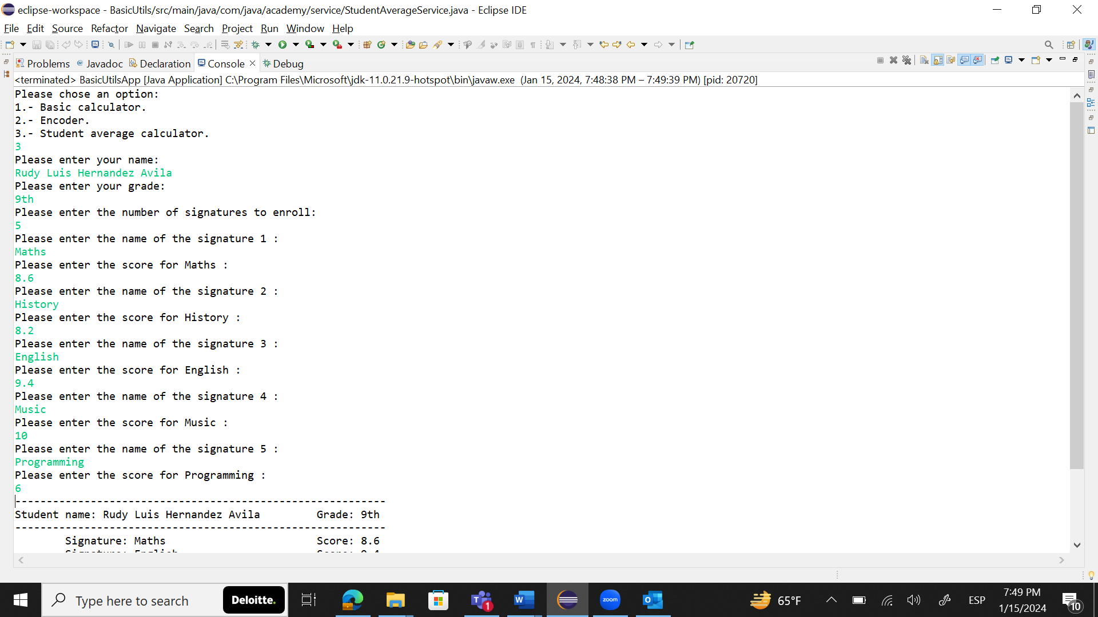

Output:

